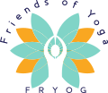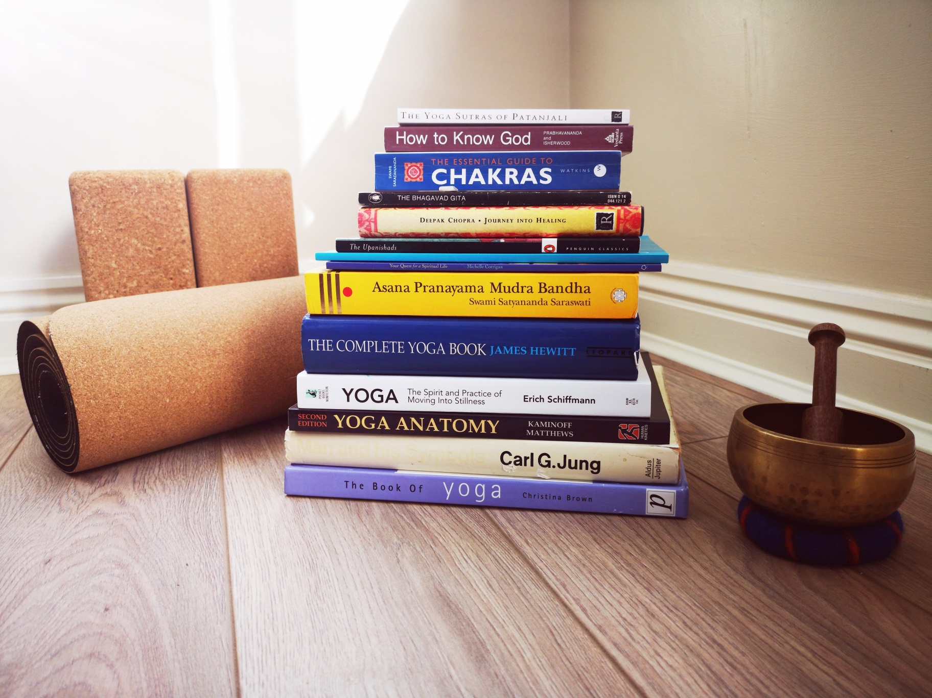

**Reading List**

**Recommended Reading:**

Eastern Body, Western Mind – Judith Anodea**

The Muscle Book – Paul Blakey***

Yoga Prescribed – Carole Kerton*

Home from Om – Carole Kerton*

The Last Yoga Retreat – Carole Kerton*

Anatomy of Hatha Yoga – David H Coultor**

Mandalas for Meditation – Ruediger Dahlke*

Learn to Meditate – David Fontana*

The Secret Language of Symbols – David Fontana***

The Encyclopedic Dictionary of Yoga – Georg Feuerstien***

Anatomy and Asana: Preventing Yoga Injuries – Susi Hately Aldous**

Yoga Anatomy – Leslie Kaminoff**

**Essential Reading:**

The Complete Book of Yoga – James Hewitt***

The Bhagavad Gita – Juan Mascaro***

The Upanishads – Juan Mascaro***

Hatha Yoga Pradipika – Swami Muktibodhananda***

How to Know God: The Yoga Aphorisms of Patanjali – Swami Prabhavananda & Christopher Isherwood***

Asana, Pranayama, Mudra, Bandha – Swami Satyananda Saraswati***